How to set up the initial pet food store PHP project

1. Download the pet-food-store project from the repo

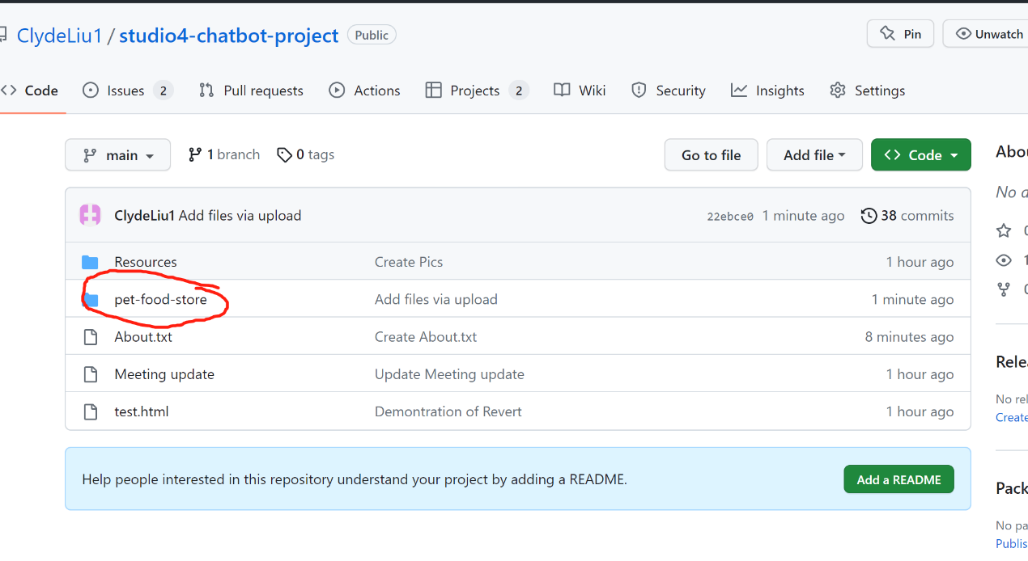

1. Open Laragon Clicking Start All then Open the Root file

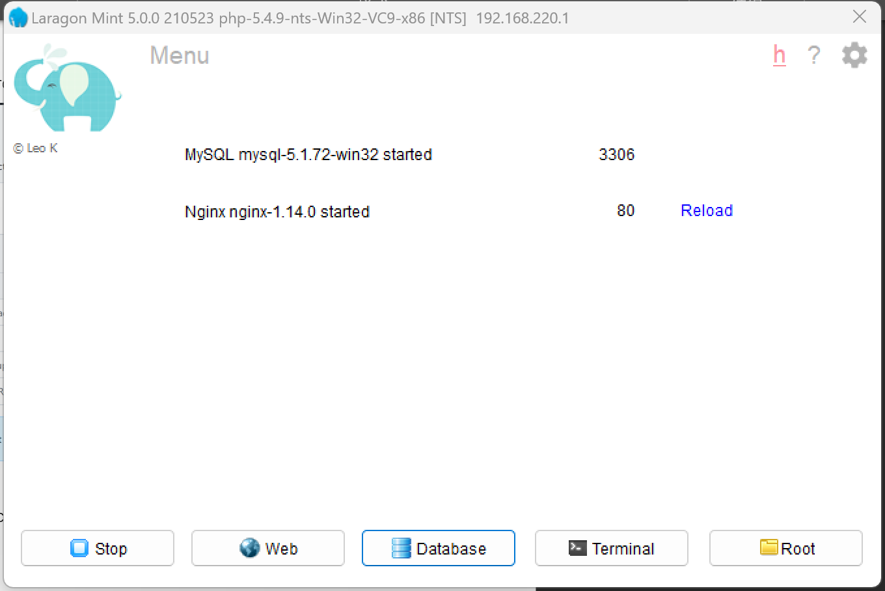

1. Cut or copy the pet-store-project file that you downloaded from GitHub, Paste in the Root file (Do not paste sql file)

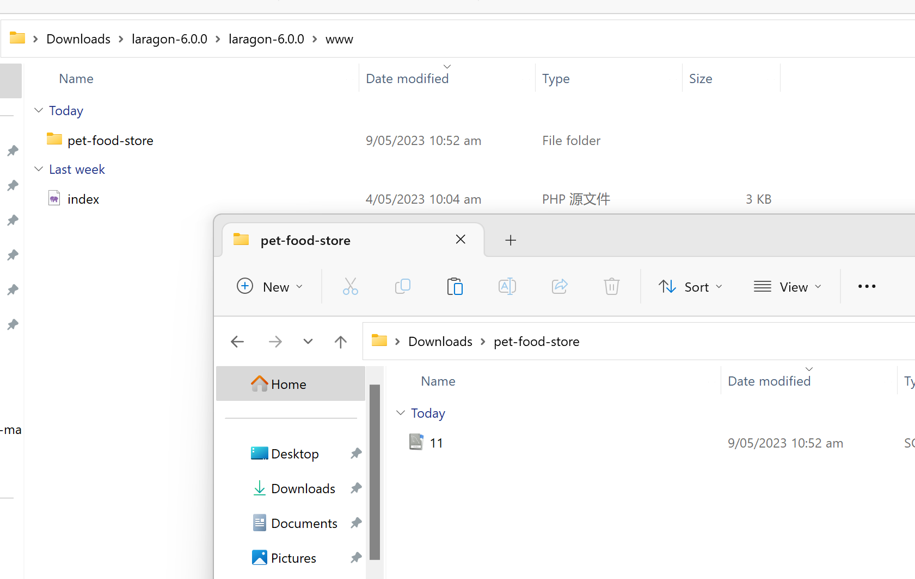

1. Open 11.SQL file with notepad+ or MySQL Copy all the code, then Open the Laragon and click the database button.

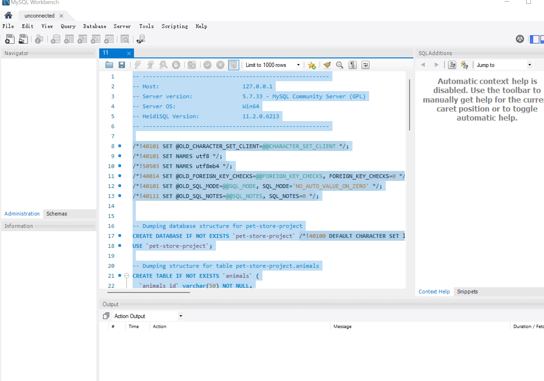

1. Create a new database and click open(Make sure the port number is the same as your laragon port number 3306)

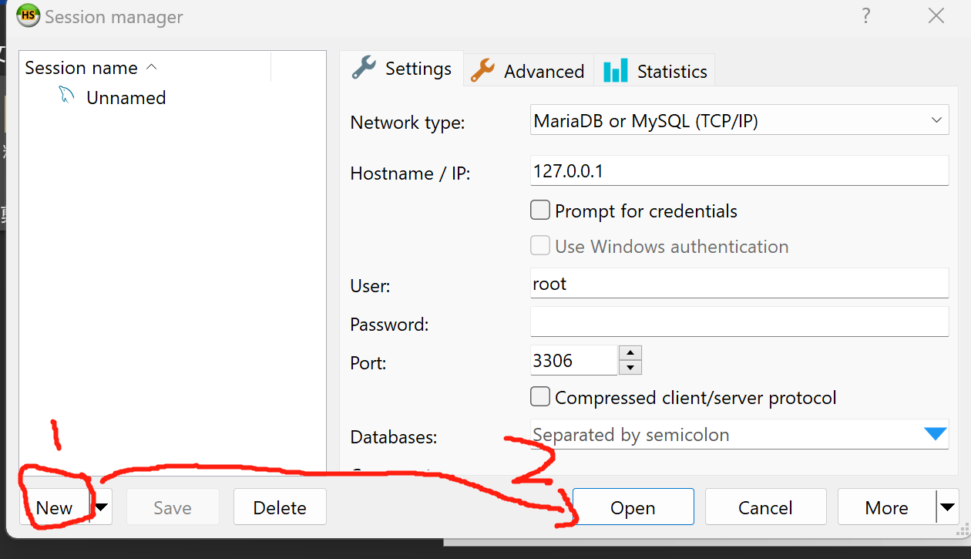

1. Paste the code that you copied to Query then click run the Query

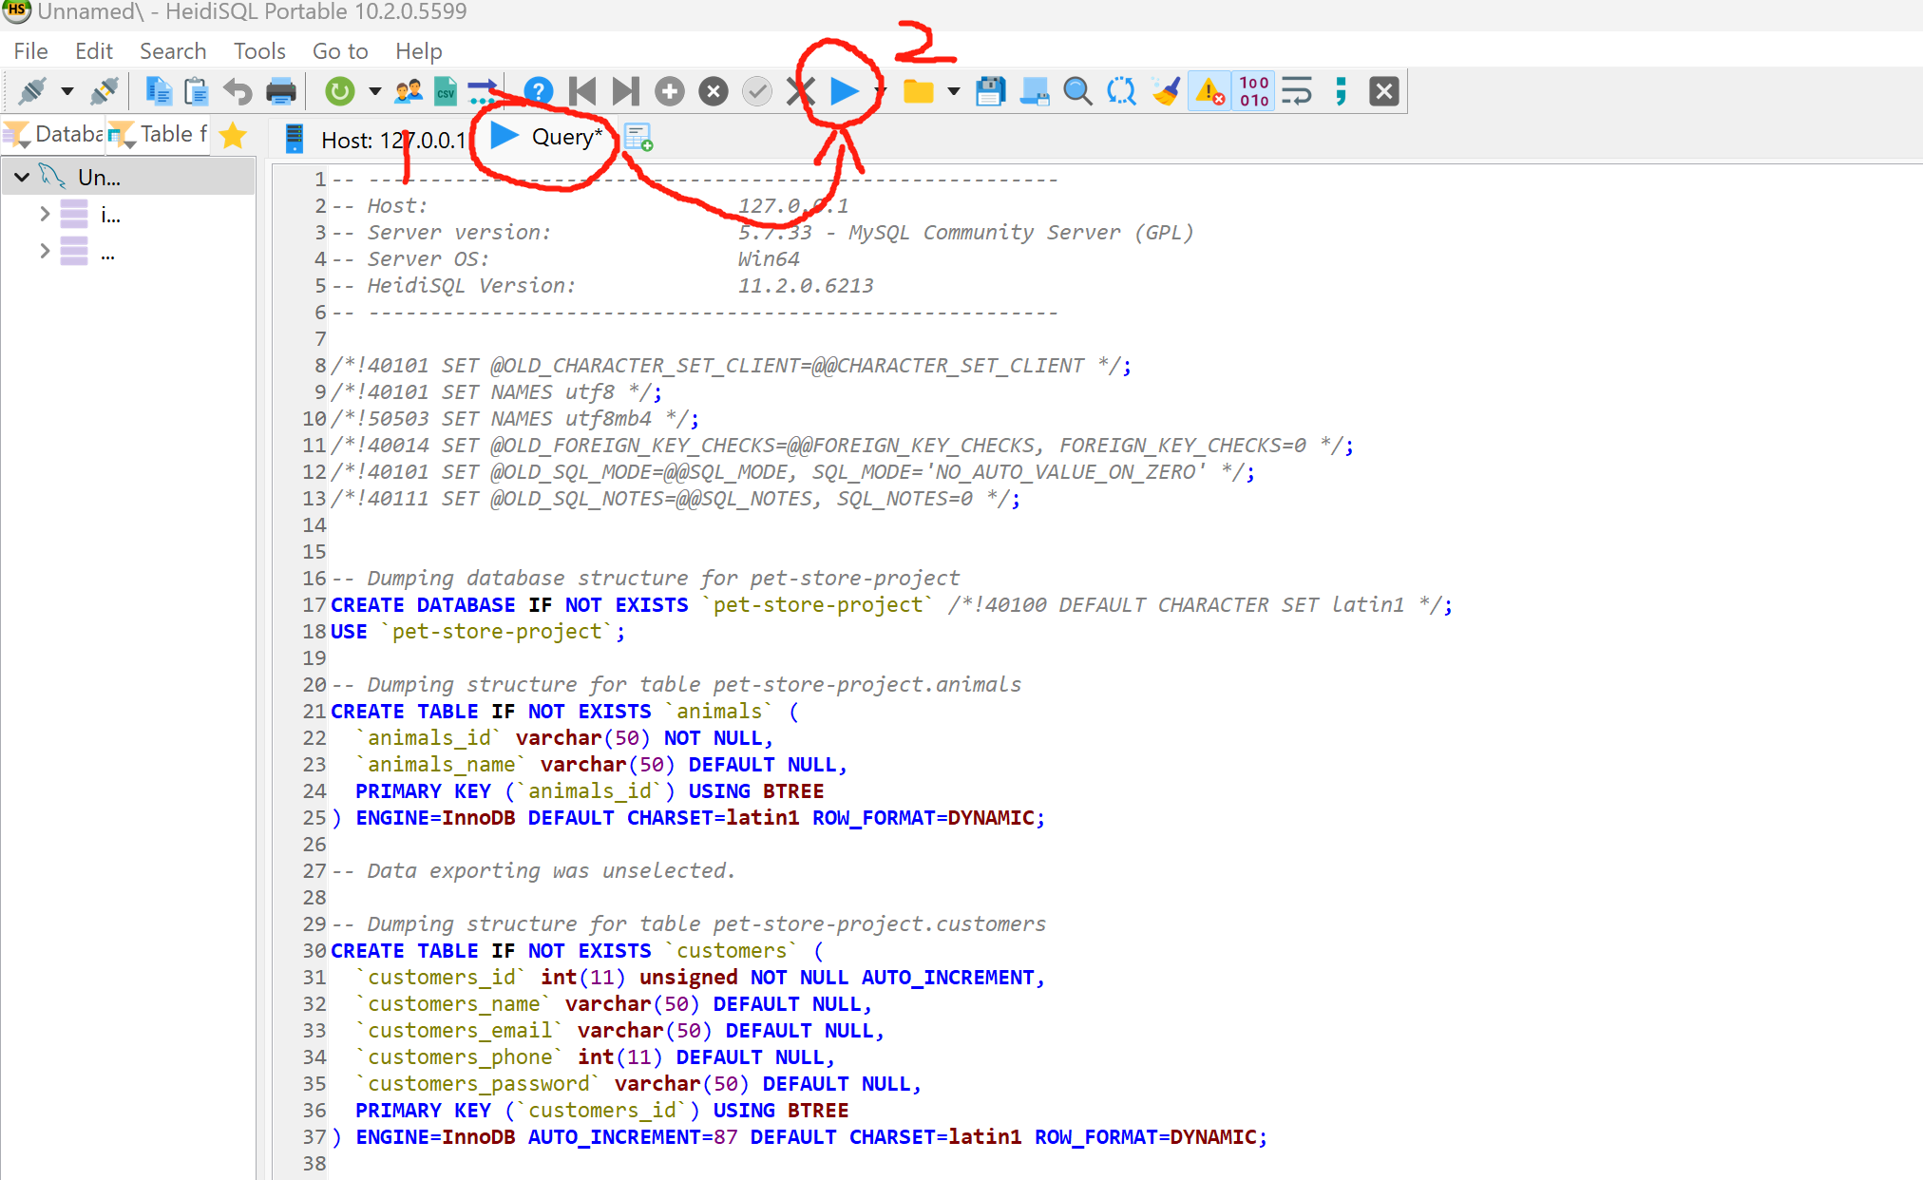

1. Right click the left menu choose refresh, then the project file will display on the menu

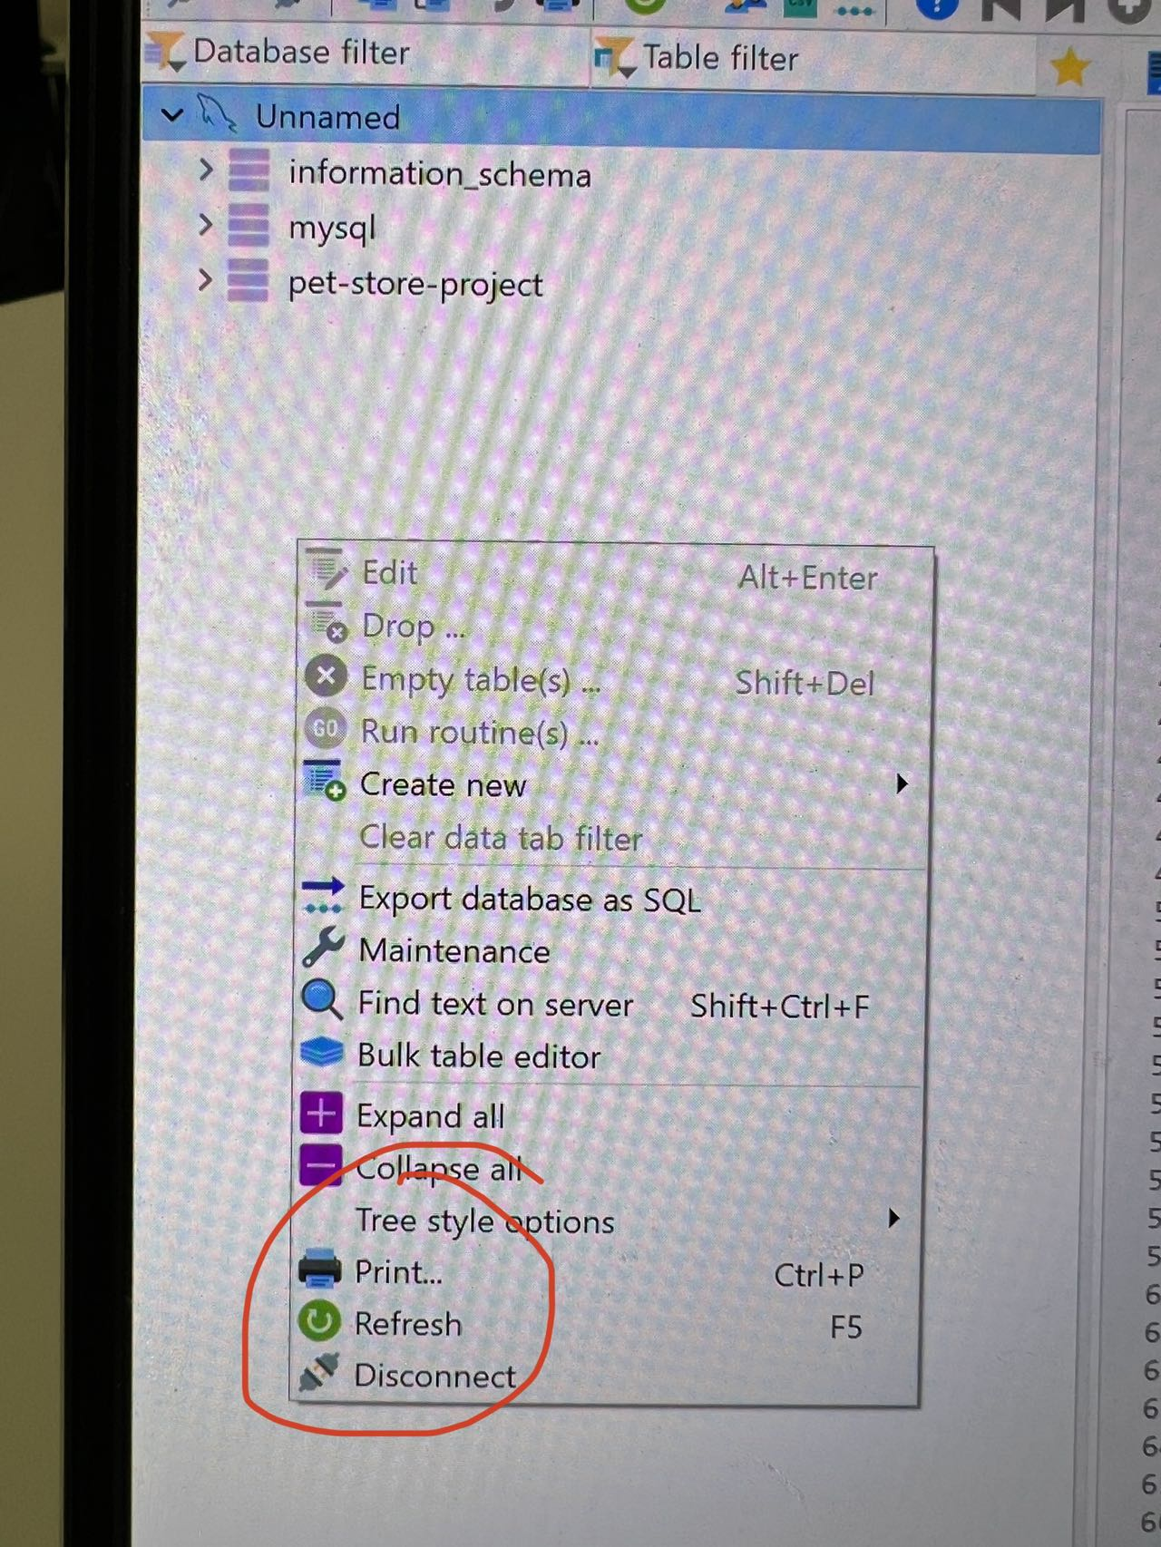

1. Open the browser tap: localhost(+your laragon port number,for example 81, 80 or none)/pet-food-store (make sure your laragon is started)

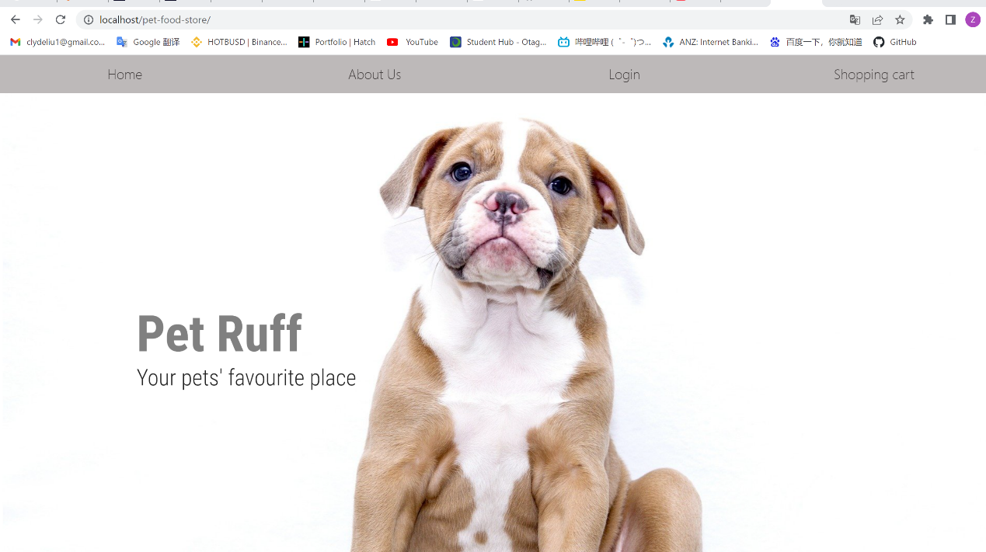



Nice All done! You should see the project now